Weekly Construction Progress Report – Week 18
Harrow Bay Offshore Wind · 27 Apr – 03 May 2026
Elena Márquez · 04 May 2026 · HB-PM-RPT-2026-W18

1. Summary
1 monopile (HB-A05) was installed this week, bringing the total to 5 of 40. The foundation campaign is 1 pile ahead of the Rev 2 baseline. Waiting on weather amounted to 9 hours.
Area | Status | Comment
Overall schedule | Green | 5/40 monopiles vs. 4 planned
Foundations | Green | TPs installed: 4
Offshore substation | Green | Fabrication / load-out
Cables | Green | Manufacturing on schedule
HSE | Green | No incidents

2. Progress
Metric | This week | Cumulative | Plan (cum.) | Variance
Monopiles installed | 1 | 5 | 4 | +1
Transition pieces installed | 1 | 4 | – | –
Waiting on weather (h) | 9 | 58 | – | –
Persons on board (avg.) | 98 | – | – | –
Man-hours MV Sea Atlas | 8,450 | 32,930 | – | –
Lost time injuries | 0 | 0 | 0 | 0
Recordable injuries | 0 | 0 | – | –
Near misses reported | 0 | 1 | – | –
HSE observation cards | 26 | – | – | –

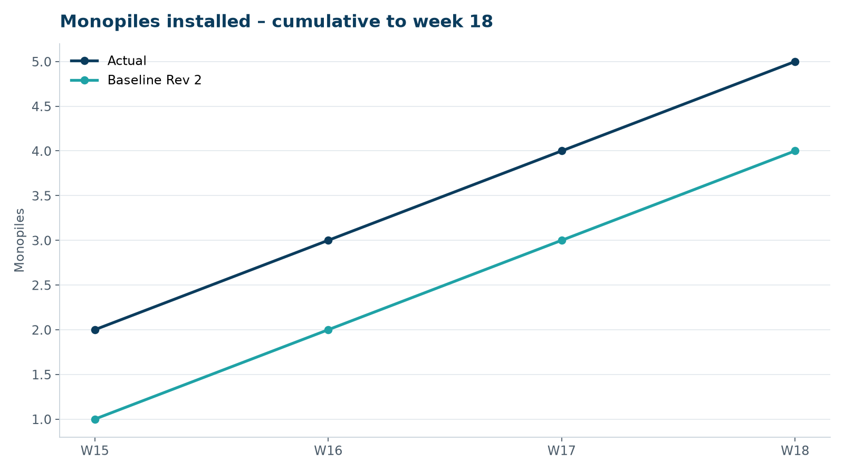
Figure 1 – Monopile installation progress, W15 to W18

3. Key activities this week
- HB-A05 installed on 3 May; transition pieces HB-A03 and HB-A04 installed.
- Marlow Ecology completed aerial seabird survey no. 4 (digital aerial survey, 12 transects).
- Guard vessel reported two strings of creel pots inside the 500 m safety zone at HB-A06; removed by the owners after contact by the Fisheries Liaison Officer.

4. Health and safety
No lost time injuries. 26 observation cards submitted; top theme: access to the TP platform.

5. Environment
- HB-A05: peak 158.1 dB SEL at 750 m (compliant); pre-piling search clear, soft start on time.

6. Issues and risks
- HB-RISK-001 weather: 9 h downtime this week.

7. Look-ahead next week
Install HB-A06 and HB-A07, weather permitting.
Prepared by Project Controls (Gareth Lewis); approved by Elena Márquez. Distribution: project team, Steering Committee, Halden Turbine Systems, Lenders' Technical Adviser.

